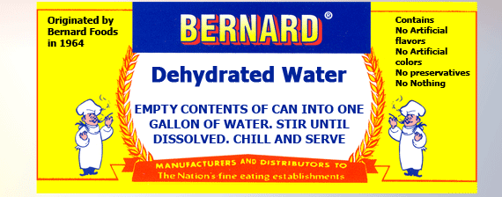

DIETETIC PRODUCTS SPECIAL USES FOR DRY H20

Literally Thousands of Uses!

Dry Martinis-Manhattans
Watering Cactus
VW Bug Anti-Freeze
Dry Cleaning
Humidifying Saunas
Filling Dry Docks
Dry Mopping Floors
In Dry Sinks
Dry Shampoos
In Dry-Cell Batteries
Dampening Dry Humor
Making Dry Ice

GLUTEN FREE

