METAM RV Metallographic Inverted Microscope
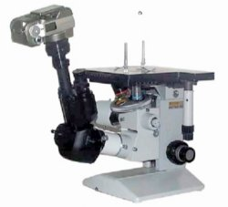
METAM RV microscopes with upper location of the stage are based on one unified stand, differing in configuration of furnished assemblies: set of objectives, eyepieces and other accessories. Various configuration options allow customers to choose the microscope in accordance with the specific character of application: metallographic microscopes – operational METAM RV-21, METAM RV-22, student-oriented METAM RV-23 are designed for visual examination of microstructure of metals, alloys and other non-transparent objects in reflected light with perpendicular bright-field and dark-field illumination, as well as for studying objects in polarized light and by differential interference-contrast (DIC) illumination method.
Specifications
 | METAM RV-21 | METAM RV-22 | METAM RV-23
Magnification | 80-1000 | 80-1000 | 80-507
Magnification of eyepieces | 10;12.5;20 | 10; 12.5; 20 | 10; 12.5
Objectives | On turret  F=25mm, A=0.17mm;  F=16mm, A=0.30mm;  F=6.3mm, A=0.60mm;  F=4.0mm, A=0.85mm; | On turret  F=25mm, A=0.17mm;  F=6.3mm, A=0.60mm;  F=4.0mm, A=0.85mm; | On turret  F=25mm, A=0.17mm;  F=6.3mm, A=0.60mm;
Objectives with DIC module | F=25mm, A=0.17mm;  F=16mm, A=0.30mm;  F=6.3mm, A=0.60mm;
Range of stage displacement, mm | 70x50 | 70x50 | 70x50
Photography capability Photographic attachment | 24x36mm (optional)
Microscope dimensions, mm | 310x280x270 | 310x280x270 | 310x280x270
Mass, kg | 8 | 7 | 6.5

